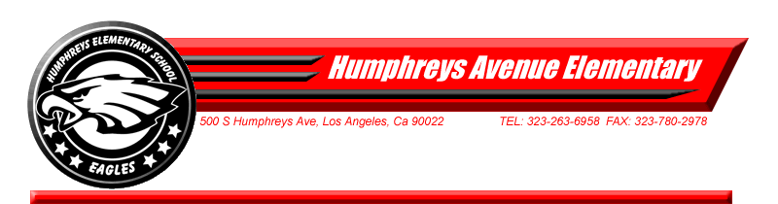Humphreys Avenue October Parent Training Schedule
Humphreys Avenue Computer Lab, 8:00 – 9:00 AM
Presented by Mr. A. Quintanar & Ms. A. Jonas
Week 5, October 8
Learn how to write a friendly letter. Practice the opening and saving of your work. Explore the Toolbar, discover how to check your spelling using MS Word.

Week 6, October 15
Learn how to format documents. Practice inserting pictures and clip art. Using MS Word, insert clip art or a picture into your letter.

Week 7, October 22,
Learn how to create a flier. Create a Halloween Parade flier; modify an existing MS Word template.

Week 8 October 29,
Digital Citizenship Week Activity, Photobooth, sending a message to their kids telling them to be safe on the computer.

